**A PROJECT REPORT**

**ON**

**i-Volunteer**

*Submitted by*

**Palak Bharucha (150410107008)**

**Nandani Dabhi (150410107014)**

**Binal Kharva (150410107034)**

***In partial fulfilment***

***Of***

**BACHELOR OF ENGINEERING**

***in***

**COMPUTER ENGINEERING**



**SARDAR VALLABHBHAI PATEL INSTITUTE OF TECHNOLOGY,**

**VASAD**

**GUJARAT TECHNOLOGICAL UNIVERSITY, AHMEDABAD**

**SARDAR VALLABHBHAI PATEL INSTITUTE OF TECHNOLOGY,**

**VASAD**

**COMPUTER ENGINEEERING DEPARTMENT**



**CERTIFICATE**

**Date: 6-10-2018**

**This is to certify that the project entitled “i-volunteer” has been carried out by Palak Bharucha(150410107008), Nandani Dabhi(150410107014), Binal Kharva(150410107034) under my guidance in partial fulfilment of the project in Bachelor of Engineering in Computer Engineering 7th semester of Gujarat Technological University, during the academic year 2018-2019.**

**Internal Guide: Head of Department:**

**Mrs. Jayna Shah Dr. Neha Soni**

**Assistant Professor C.E. Department**

**S.V.I.T. Vasad S.V.I.T. Vasad**

**TABLE OF CONTENTS**

|  |  |  |
| --- | --- | --- |
| **CHAPTER 1 INTRODUCTION** |  | **1** |
| * 1. INTRODUCTION   2. EXISTING SYSTEM   3. NEED FOR THE NEW SYSTEM   4. OBJECTIVE OF THE NEW SYSTEM   5. PROBLEM DEFINITION   6. ADVANTAGES AND LIMITATIONS OF THE PROPOSED SYSTEM |  | **1**  **1**  **1**  **2**  **2**  **2** |
| **CHAPTER 2 REQUIREMENT GATHERING** |  | **3** |
| 2.1 FUNCTIONAL REQUIREMENT |  | **3** |
| 2.2 NON FUNCTIONAL REQUIREMENT |  | **3** |
| 2.3 HARDWARE REQUIREMENT |  | **4** |
| 2.4 SOFTWARE REQUIREMENT |  | **4** |
| **CHAPTER 3 FEASIBILITY STUDY** |  | **5** |
| 3.1 TECHNICAL FEASIBILITY |  | **5** |
| 3.2 TIME FEASIBILITY |  | **6** |
| 3.3 ECONOMIC FEASIBILITY |  | **6** |
| **CHAPTER 4 SYSTEM DESIGN** |  | **7** |
| 4.1 SYSTEM MODEL |  | **7** |
| 4.2 SYSTEM ARCHITECTURE |  | **8** |
| 4.3 SYSTEM DIAGRAM |  | **9** |
| 4.3.1 CLASS DIAGRAM |  | **9** |
| 4.3.2 USE CASE DIAGRAM |  | **9** |
| 4.3.3 ACTIVITY DIAGRAM |  | **10** |
| 4.3.4 SEQUENCE DIAGRAM |  | **11** |
| 4.3.5 DATA FLOW DIAGRAM |  | **12** |
| **CHAPTER 5 DATABASE DESIGN** |  | **13** |
| 5.1 ER DIAGRAM |  | **13** |
| 5.2 DATA DICTIONARY |  | **14** |
| **CHAPTER 6 SOFTWARE DESCRIPTION**  6.1 SOFTWARE DESCRIPTION |  | **15** |
| **CHAPTER 7 CANVAS** |  | **16** |
| 7.1 EMPATHY MAPPING CANVAS |  | **16** |
| 7.2 IDEATION CANVAS |  | **17** |
| 7.3 PRODUCT DEVELOPMENT CANAVAS |  | **19** |
| 7.4 AEIOU CANVAS |  | **20** |
| **CHAPTER 8 CONCLUSION** |  | **22** |
| **CHAPTER 9 REFERENCES** |  | **23** |
| 9.1 REFERENCE |  | **23** |
|  |  |  |
|  |  |  |
|  |  |  |
|  |  |  |
|  |  |  |
|  |  |  |
|  |  |  |
|  |  |  |

**ACKNOWLEDGEMENT**

We take this opportunity to express our profound sense of gratitude and respect to all those who helped us throughout the duration of this project***.***

Firstly, we are extremely grateful to Sardar Vallabhbhai Patel Institute of Technology, VASAD for providing us the excellent working environment to undergo our project.

We devote our success in this effort to our project guide **Mrs. Jayna Shah** for giving us the opportunity to undertake the project and providing crucial feedbacks that influenced us and provide opportunity to undertake the project work in the esteemed concern.

We are also deeply thankful to **Dr. Neha Soni, Head of Department of SVIT** whose useful suggestions, gentle attitude and right directions helped us a lot to learn in this project and also for her constant encouragement and support throughout the project.

Also we are very thankful to all the faculty members of computer department for their kind help and great response towards the problem related to our project report.

Our special thanks to **GUJARAT TECHNOLOGY UNIVERSITY** whose continuous encouragement, suggestions and constructiveness have been invaluable assets throughout our report analysis.

**ABSTRACT**

i-Volunteer is a web portal and mobile application, that provides a platform wherein any individual or a group of people can voluntarily contribute towards the society by conducting activities like teaching, organizing camps, donating etc. The portal also provides a facility through which schools running in villages or the village panchayat can register themselves and connect to the volunteers.

At the time of registration, the schools have to provide their requirements. All these details will be displayed on the portal, the candidates can search for the appropriate schools and apply for schools. If the school finds the candidate appropriate, then he/she will be notified of their selection.

By logging in, the registered institutions can also manage the applications received by them. The candidates can get a summary of the places they have applied and worked with previously, working at present, and willing to work in future.

If any individual wants to contribute by other means like donation or organizing camps, they can fill a form and further procedures will be handled by the administrator.

The portal also provides reviews, experiences and the on-going activities conducted in the villages and tribal towns. The registered volunteers can ask questions and they will be answered by the administrator.

**CHAPTER 1**

**INTRODUCTION**

* 1. **INTRODUCTION**

Majority of India live in villages and so the topic of rural education in India is of utmost importance. A survey named called the Annual Status of Education Report (ASER), shows that even though the number of rural students attending schools is rising, but more than half of the students in fifth grade are unable to read a second-grade text book and are not able to solve simple mathematical problems. In some of the government schools there is only one teacher for the entire school. There are fewer committed teachers, lack of proper text books and learning material in the schools. Due to lack of money they are not able to send their children to private schools and hence depend upon government schools for education.

There is a difference between city and village student in terms of environment, skills, learning ability, availability of infrastructure, and access to different facilities.

Every village is not provided with school so, students have to go to another village to get education. Some parents do not send their daughter to study.

**1.2 Existing System**

There are many systems which provide the volunteers and donors a platform to donate money, but the money is rarely used for the betterment of people and in the way the donors want it to be used. Secondly there are many portals available, but there is no proof of their authenticity and fake. Few people who have contributed have also faced fraud calls and fixed up in crimes and cases.

On the other side the bond between the village and the city is very weak, and so the villagers feel isolated. In spite of programmes conducted by the government, there is no notable change seen in the development in the villages. To obtain overall development, both the cities and the villages have to work together hand in hand.

* 1. **Need for the new System**

There are six lakh villages in India (Census 2011). Of the 121 crore Indians, 83.3 crore (68.84%) live in rural areas while 37.7 crore stay in urban areas. The people living in urban areas somehow manage to earn good money and fulfil their basic needs. Whereas, the people in the rural areas and villages are often deprived of quality education, health, employment, and other aspects of life style.

The people living in urban areas, people from well-to-do families, and people belonging to business families and also the big institutions, governmental bodies, private companies, NGOs etc often donate money, conduct camps, and help people in need. There are large number of people who are in need of help and a large number of people living to help. But there is a gap between these ends, which can be built through a platform like i-Volunteer.

* 1. **Objective of the new System**

i-Volunteer is a web portal and mobile application, that provides a platform wherein any individual or a group of people can voluntarily contribute towards the society by conducting activities like teaching, organizing camps, donating etc. The portal also provides a facility through which schools running in villages or the village panchayat can register themselves and connect to the volunteers.

At the time of registration, the schools have to provide their requirements. All these details will be displayed on the portal, the candidates can search for the appropriate schools and apply for schools. If the school finds the candidate appropriate, then he/she will be notified of their selection.

By logging in, the registered institutions can also manage the applications received by them. The candidates can get a summary of the places they have applied and worked with previously, working at present, and willing to work in future.

If any individual wants to contribute by other means like donation or organizing camps, they can fill a form and further procedures will be handled by the administrator.

The portal also provides reviews, experiences and the on-going activities conducted in the villages and tribal towns. The registered volunteers can ask questions and they will be answered by the administrator.

**1.5 Problem Definition**

**1.6 Advantages and Limitations of the Proposed System**

* Effective way to connect the volunteers and NGOs to the services
* Effective way to donate money
* Effective way to connect the villagers to the cities
* Encourages more people to donate and help
* Difficult to connect the villages without the computer and internet facilities
* Needs a capable and enthusiastic group of people to operate the back-end functions

**CHAPTER 2**

**REQUIREMENT GATHERING**

**2.1 FUNCTIONAL REQUIREMENTS**

In software engineering, a functional requirement refers to a function of a system or its component, where a function is described as a specification of behaviour between outputs and inputs. Functional requirements include calculations, technical details, data manipulation and processing and other specific functionality that define what a system is supposed to fulfil. Functional requirements are supported by non-functional requirements, which imply constraints on the design or implementation. Generally, functional requirements are expressed in the form “system must fulfil (requirement)”.

1. Registration

2. Login

3. Authentication

4. Profile editing

5. Profile display

6. Validation

7. Searching

8. Sorting

9. Chatbot

10. Updation

**2.2 NON-FUNCTIONAL REQUIREMENTS**

1. **Scalability**

With regards to the intended number of users and the projected load scenarios, the intention is for the system to be able to handle the traffic and display all the portals.

1. **Performance Requirements**

Performance requirements define acceptable response times for system functionality. Although the system is developed suiting for the least system performances, the performance of the system will highly depend on the performance of software components of the installing computer. When consider about the timing relationships of the system the load time for user interface screens shall take no longer than two seconds. It makes fast access to system functions. The login information shall be verified within five seconds causes’ efficiency of the system.

1. **Security and privacy**

Requirements can dictate protection for sensitive information. Some types of privacy requirements include data encryption for database tables, policies regarding the transmission of data to 3rd parties.

**2.3 HARDWARE REQUIREMENTS**

Android supported device

Computer/Laptop/Mobile/others

**2.4 SOFTWARE REQUIREMENTS**

1. Ecllipse
2. Android(Mobile Application)
3. My SQLite(Database Management)
4. Supported Database and library that supports the database connection with Java

**CHAPTER 3**

**FEASIBILITY STUDY**

A feasibility study is an analysis used in measuring the ability and likelihood to    complete a project successfully including all relevant factors. It must account for factors that affect it such as economic, technological, legal and scheduling factors. Project managers use feasibility studies to determine potential positive and negative outcomes of a project before [investing](https://www.investopedia.com/terms/i/investing.asp) a considerable amount of time and money into it.

Feasibility studies allow companies to determine and organize all the details to make a business work. A feasibility study helps identify logistical problems, and nearly all business-related problems and their solutions. Feasibility studies can also lead to the development of marketing strategies that convince investors or a bank that investing in the business is a wise choice.  
There are several components of a feasibility study:

**3.1 TECHNICAL FEASIBILITY**

* The project is a complete web based application. The main associated tools involved are as follows:
* HTML
* CSS
* JSP
* MYSQL
* Diagram drawing tool: smartdraw
* Internet facility

**3.2 TIME FEASIBILITY**

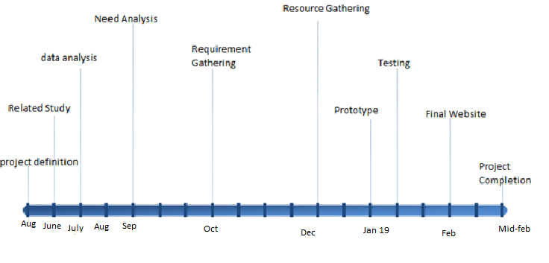

(Figure 3.2.1 Timeline Chart)

As per the timeline chart made by our group, all our modules will be completed within time limit. Also, considering experience of an industrial guide, project is time bound.

* 1. **ECONOMIC FEASIBILITY**
* Software development will be done through Android Studio which is open source. Cost incurred software development to produce long term gains for an organisation.
* Eclipse, Bootstrap are open source.
* Product cost should be optimised.

**CHAPTER 4**

**SYSTEM DESIGN**

**4.1 SYSTEM MODEL**

Agile SDLC model is a combination of iterative and incremental process models with focus on process adaptability and customer satisfaction by rapid delivery of working software product. Agile Methods break the product into small incremental builds. These builds are provided in iterations. Each iteration typically lasts from about one to three weeks. Every iteration involves cross functional teams working simultaneously on various areas like −

* Planning
* Requirements Analysis
* Design
* Coding
* Unit Testing and
* Acceptance Testing.

At the end of the iteration, a working product is displayed to the customer and important stakeholders.

The Agile Process Flow

* Concept - Projects are envisioned and prioritized
* Inception - Team members are identified, funding is put in place, and initial environments and requirements are discussed
* Iteration/Construction - The development team works to deliver working software based on iteration requirements and feedback
* Release - QA (Quality Assurance) testing, internal and external training, documentation development, and final release of the iteration into production
* Production - Ongoing support of the software
* Retirement - End-of-life activities, including customer notification and migration
* This view presents the full Agile lifecycle model within the enterprise. In any enterprise there may be projects operating simultaneously, multiple sprints/iterations being logged on different product lines, and a variety of customers, both external and internal, with a range of business needs.

**4.2 SYSTEM ARCHITECTURE**

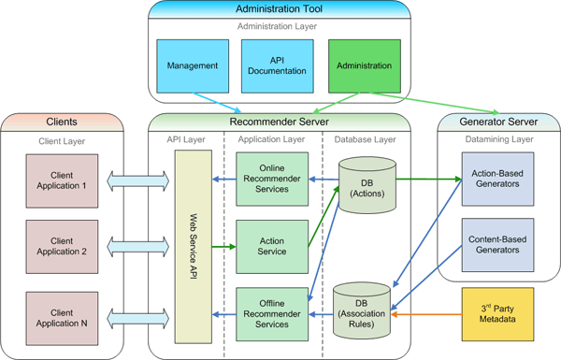

(Figure 4.2.1 System architecture)

Web application architecture defines the interactions between applications, [middleware](http://searchmicroservices.techtarget.com/definition/middleware) systems and databases to ensure multiple applications can work together. When a user types in a URL and taps “Go,” the browser will find the Internet-facing computer the website lives on and requests that particular page.

The server then responds by sending files over to the browser. After that action, the browser executes those files to show the requested page to the user. Now, the user gets to interact with the website. Of course, all of these actions are executed within a matter of seconds. Otherwise, users wouldn’t bother with websites.

What’s important here is the code, which has been parsed by the browser. This very code may or may not have specific instructions telling the browser how to react to a wide swath of inputs. As a result, web application architecture includes all sub-components and external applications interchanges for an entire software application.

Of course, it is designed to function efficiently while meeting its specific needs and goals. Web application architecture is critical since the majority of global network traffic, and every single app and device uses web-based communication. It deals with scale, efficiency, robustness, and security.

* 1. **SYSTEM DIAGRAM**

**4.3.1 CLASS DIAGRAM**

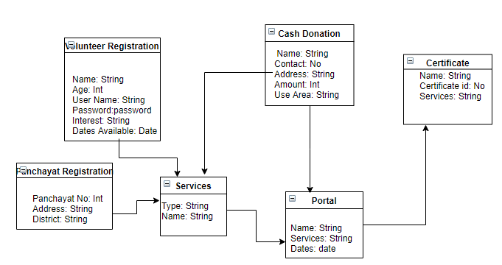

**4.3.2 USE CASE DIAGRAM**

The diagram below is use case for our System. If the user is new he will register and if he is not, he will directly login.

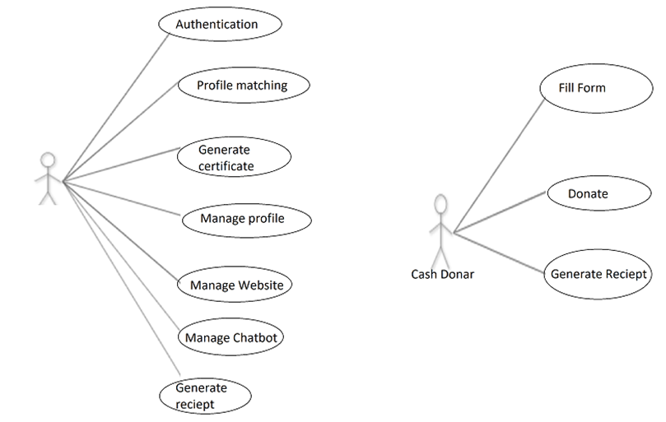

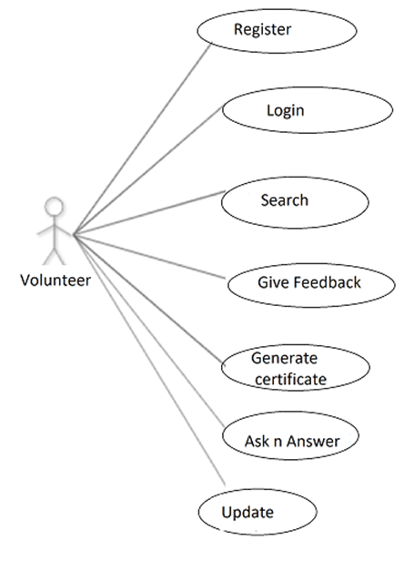

**4.3.3 ACTIVITY DIAGRAM**

The Activity Diagram below shows the activities performed by the user that consists of the user signing up and logging into the system if login credentials are correct and then he can create, edit or manage his portals.

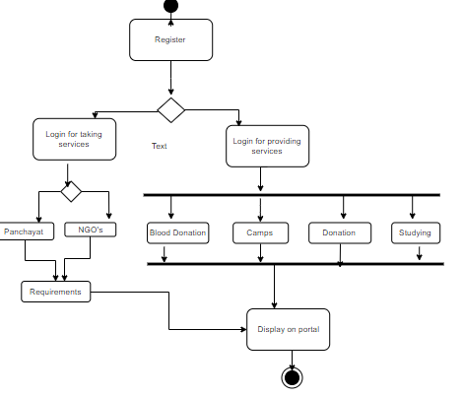

**4.3.4 SEQUENCE DIAGRAM**

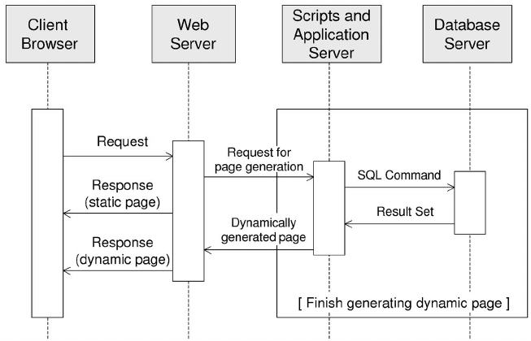

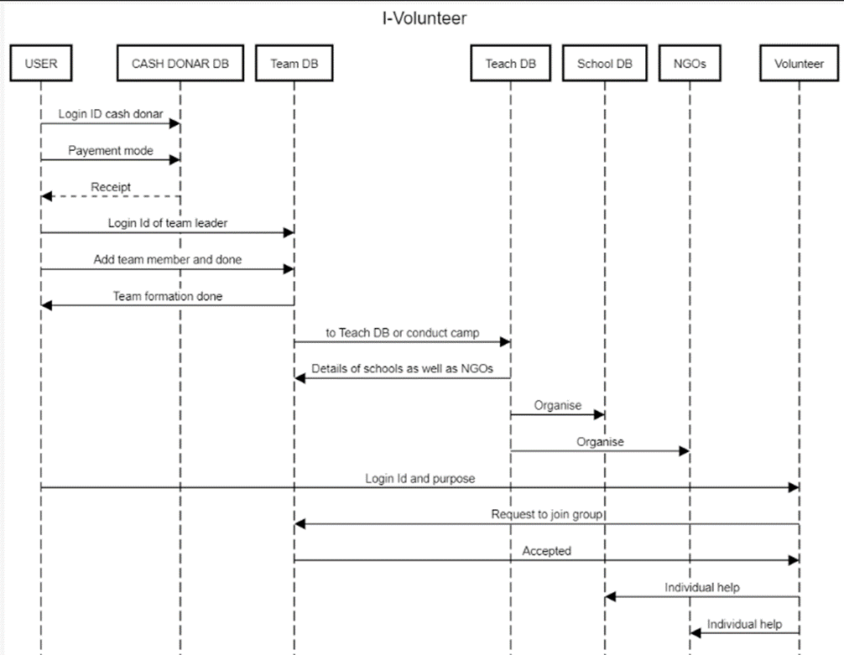

**4.3.5 DATA FLOW DIAGRAM (DFD)**

**LEVEL 0**

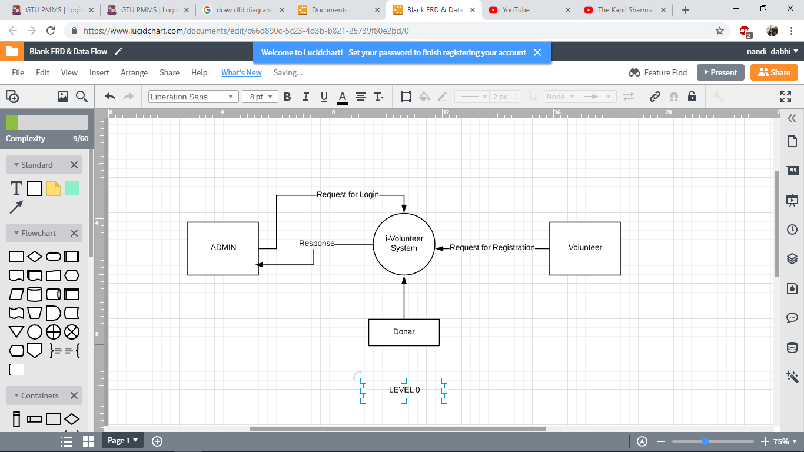

**LEVEL 1 (Admin Side)**

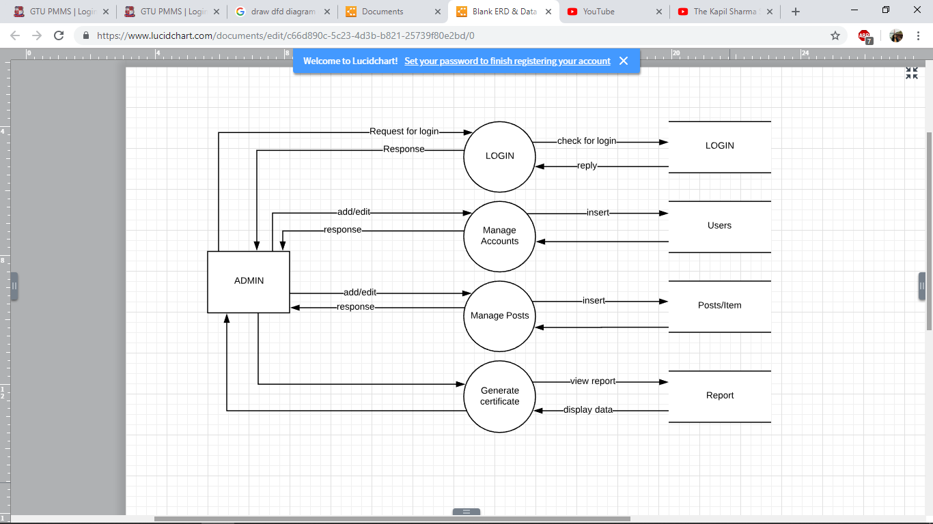

**LEVEL 1 (User Side)**

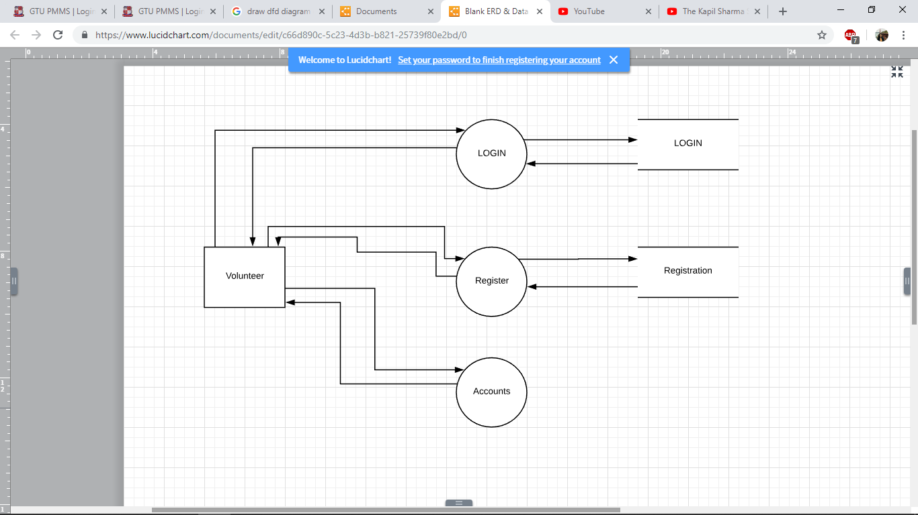

**CHAPTER 5**

**DATABASE DESIGN**

**5.1 ER DIAGRAM**

The ER- Diagram shows the relationships between various classes of our application and their various attributes.

At first glance an entity relationship diagram looks very much like a [flowchart](https://www.smartdraw.com/flowchart/). It is the specialized symbols, and the meanings of those symbols, that make it unique.

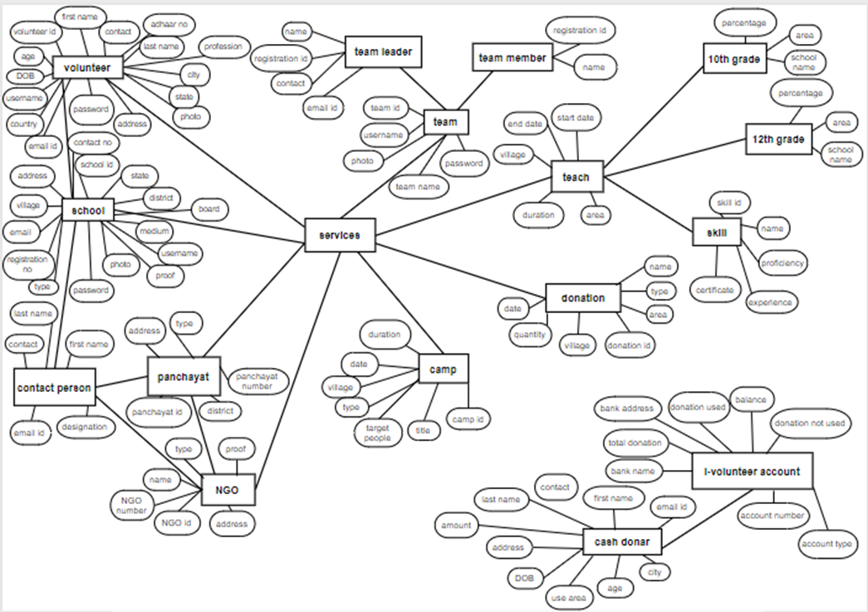

**5.2 DATA DICTIONARY**

|  |  |  |
| --- | --- | --- |
| **NAME** | **DATA TYPE** | **PERSON** |
| Volunteer Name | Text | Volunteer, Donor, NGOs |
| Date of birth | Date | Volunteer, Donor, NGOs |
| Gender | Radio | Volunteer, Donor, NGOs |
| Contact Number | Numeric | Volunteer, Donor, NGOs |
| Alternate Contact Number | Numeric | Volunteer, Donor, NGOs |
| Email Id | Text | Volunteer, Donor, NGOs |
| Address | Text | Volunteer, Donor, NGOs |
| City | Text | Volunteer, Donor, NGOs |
| State | Text | Volunteer, Donor, NGOs |
| Country | Text | Volunteer, Donor, NGOs |
| Pin code | Numeric | Volunteer, Donor, NGOs |
| Age | Numeric | Volunteer, Donor, NGOs |
| Username | Text | Volunteer, Donor, NGOs |
| Password | Text | Volunteer, Donor, NGOs |
| Services | Checkbox | Volunteer, Donor, NGOs |
| Profession | Radio | Volunteer, Donor, NGOs |
| Photo | File | Volunteer, Donor, NGOs |
| Aadhaar Card Number | Numeric | Volunteer, Donor, NGOs |
| Leader Name | Text | Team |
| Registration Number | Numeric | Team |
| Member Registration ID | Numeric | Team |
| Area of Donation | Text | Donor, NGOs |
| Amount | Numeric | Donor |

**CHAPTER 6**

**SOFTWARE DESCRIPTION**

* Eclipse IDE for Java EE Developers 3.3

Eclipse can be downloaded from <http://www.eclipse.org/downloads/>. The Eclipse IDE for Java EE Developers distribution packages together all of the Web Tools Platform components and their dependencies in a convenient all-in-one download archive. To install, simply extract the archive to your hard drive.

Building Apache Tomcat requires a Java 8 JDK to be installed.

* Tomcat 7.0

You can download JDKs from Oracle  
<http://www.oracle.com/technetwork/java/javase/downloads/index.html>  
or from another JDK vendor.

Tomcat 7.0 SVN repository URL: <https://svn.apache.org/repos/asf/tomcat/tc7.0.x/trunk/>

Tomcat source packages: <https://tomcat.apache.org/download-70.cgi>.

Checkout the source using SVN, selecting a tag for released version or trunk for the current development code, or download and unpack a source package.

* Derby Plugin for Eclipse  
  Get the Derby Plugin for Eclipse (derby_core_plugin_10.2.2.zip and derby_ui_plugin_1.1.0.zip), available at <http://db.apache.org/derby/derby_downloads.html>.

JRE 6.0  
Sun's JRE is available from <http://java.com/en/download/manual.jsp>

**User Interface**

* Bootstrap

**Bootstrap** is a [free and open-source](https://en.wikipedia.org/wiki/Free_and_open-source_software) front-end [framework](https://en.wikipedia.org/wiki/Application_framework) for designing [websites](https://en.wikipedia.org/wiki/Website) and [web applications](https://en.wikipedia.org/wiki/Web_application). It contains [HTML](https://en.wikipedia.org/wiki/HTML)- and [CSS](https://en.wikipedia.org/wiki/CSS)-based design templates for [typography](https://en.wikipedia.org/wiki/Typography), forms, buttons, navigation and other interface components, as well as optional [JavaScript](https://en.wikipedia.org/wiki/JavaScript) extensions. Unlike many earlier web frameworks, it concerns itself with [front-end development](https://en.wikipedia.org/wiki/Front-end_web_development) only. Version v-4.1.3

Download: <http://getbootstrap.com/docs/4.0/getting-started/download/>

**CHAPTER 7**

**CANVAS**

**7.1 EMPATHY MAPPING CANVAS**

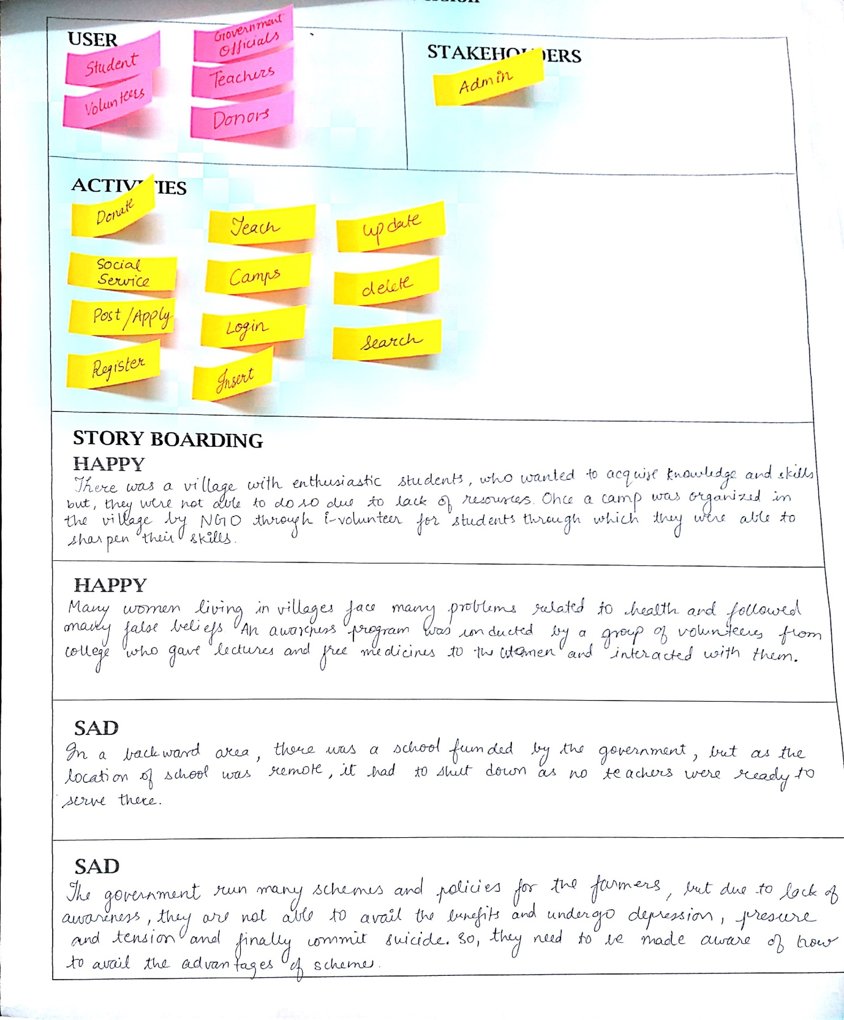

Users

* Student
* Volunteer
* Teacher
* Donor
* Government Officials

Stakeholders

* Admin

Basic activities of users and stakeholders include –

* Donate
* Social Service
* Post/ Apply
* Register
* Teach
* Camp
* Login
* Insert
* Update
* Delete
* Search

**7.2 IDEATION CANVAS**

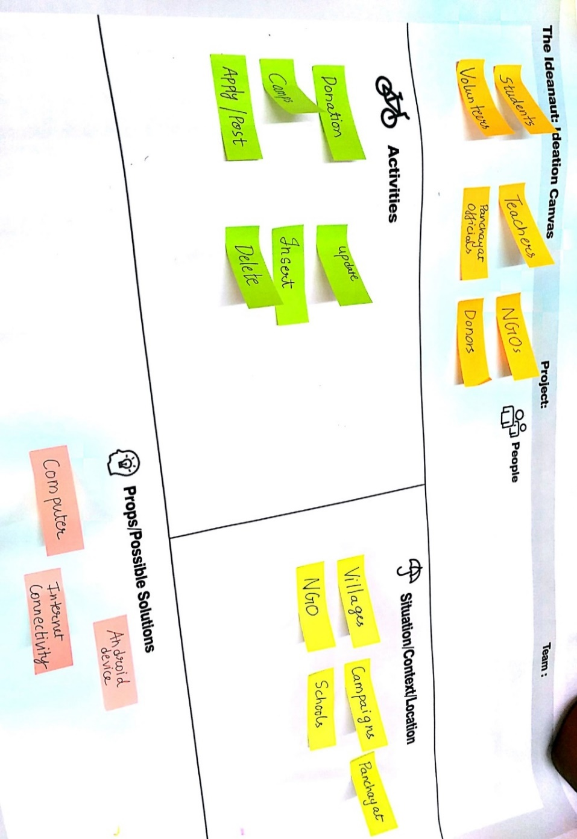

**People:**

* Student
* Volunteer
* Teacher
* Donor
* Government Officials

**Activities**

* Donate
* Social Service
* Post/ Apply
* Register
* Teach
* Camp
* Login
* Insert
* Update
* Delete

**Situation / Context / Location:**

* Village
* NGO
* School
* Panchayat
* Campaign

**Props:**

* Computer
* Android
* Internet

**7.3 PRODUCT DEVELOPMENT CANVAS**

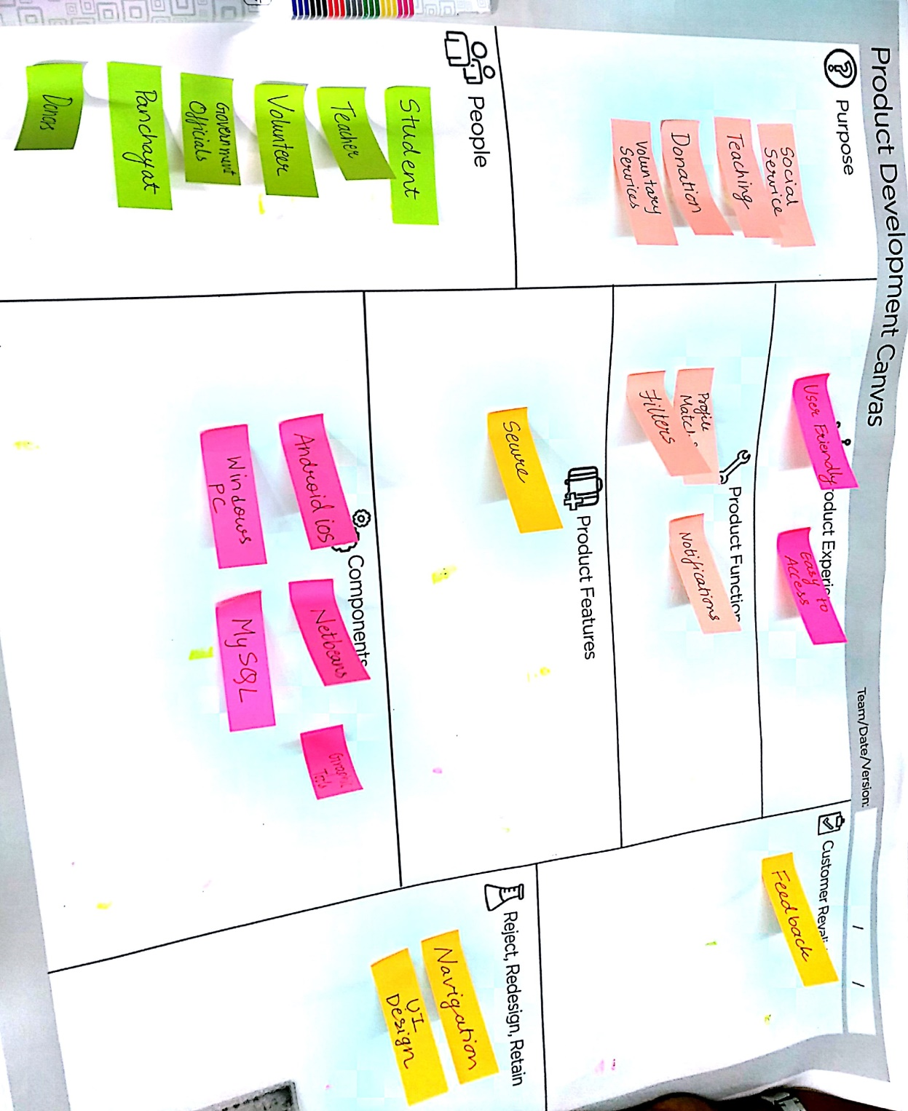

**Product experience**

* User friendly
* Easy to access

**Purpose:**

* Donation
* Social service
* Voluntary service
* Teaching

**Product Functions:**

* Match profile
* Filter
* Navigation

**Product Features:**

* Secure

**Components:**

* Android
* My sql
* Windows pc
* Graphic tools

**Customer revalidation:**

* Feedback

**Reject, Redesign, And Retain**:

We will ensure that user get a good Interface and easy navigation from one page to another.

**7.4 AEIOU CANVAS**

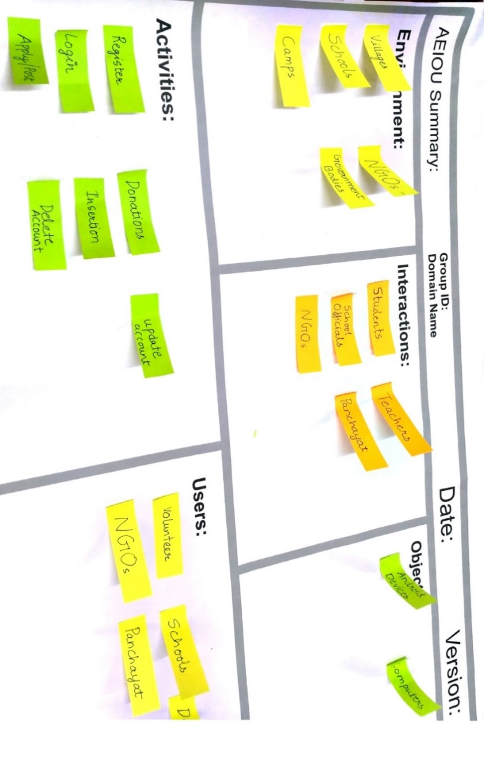

**Interactions:**

We are creating a network where people at different level can easily communicate, like families-meeting their relatives, business people-attending meetings, youth-going for camping and trekking and transport agents-booking tickets.

**Objects:**

We are developing a product which is available at each and every level and every platform like mobiles, smartwatches and computers. Also user associated with our application will interact with different objects such as suitcase, tents, camera, sleeping bags and backpacks.

**Activities:**

Various activities that user will do is attending meetings, sightseeing, playing, eating, booking, trekking, travelling, and preserving travel memories.

**Users:**

Our services cover a huge area of people like youth, students, families, transport agents, business people, senior citizens, and couples. Everyone can use our service for their convenience and get their work done in very effective manner.

**CHAPTER 8**

**CONCLUSION**

i-volunteer is an outcome of an initiative taken to solve the problem faced by the using technology to connect the volunteers and the needful people. If all the technical, functional, non-functional, hardware and software requirements are fulfilled properly, together with an enthusiastic and hard-working team, this project can be proved very useful and helpful to the villagers, NGOs, government, volunteers as well as mankind.

**CHAPTER 9**

**REFERENCES**

1. <https://www.mapsofindia.com/my-india/education/india-needs-education-especially-rural-education>
2. <http://www.ruchi.org.in/volunteering/volunteer-india-program/>
3. <http://www.rtegujarat.org/Home/SchoolList>
4. <http://cos.gujarat.gov.in/>